# S2 Detailed Methodology

This supplementary document details the basis behind the developed models and methods, as well as the overall architecture. When assessing economic viability of the complete system there were three key aspects: (1) Assessing operation Expenditure (OPEX), (2) Assessing Capital Expenditure (CAPEX), (3) Assessing Gross Revenue. As previously mentioned, this system has three key components: (1) Carbon Capture, (2) Carbon Conversion, and (3) Separation. The focus of this TEA was the costing of the Carbon Conversion portion of this subsystem, being the novel aspect of this system.

## System boundaries

In Techno-Economic Analysis (TEA), setting clear boundaries for the system and its subsystems is essential. It helps focus the study on the right areas, making the analysis more accurate and useful. By knowing exactly what to include, we can better compare technologies and make informed decisions. Also, understanding how different parts interact within these boundaries can highlight where improvements are needed. This approach ensures that TEA is both thorough and relevant, while also providing an accurate measure for limitations of the assessment. Thus, effectively guiding the development of cost-effective technologies.

1. **Carbon capture** focuses on the efficient capture and removal of carbon dioxide (CO2) from sources, such as power plants, industrial facilities, or the atmosphere.
2. **Carbon conversion** transforms captured CO2 into value-added products or fuels through a bio electrochemical reactor. This is the novel part of the system.
3. **Separation** focuses on refining and purifying the product stream to meet purity requirements for downstream applications.

By integrating these three key aspects, CCU presents a pathway to mitigate CO2 emissions while creating opportunities for resource recycling. A simplified network schematic is shown in Figure S2.1.

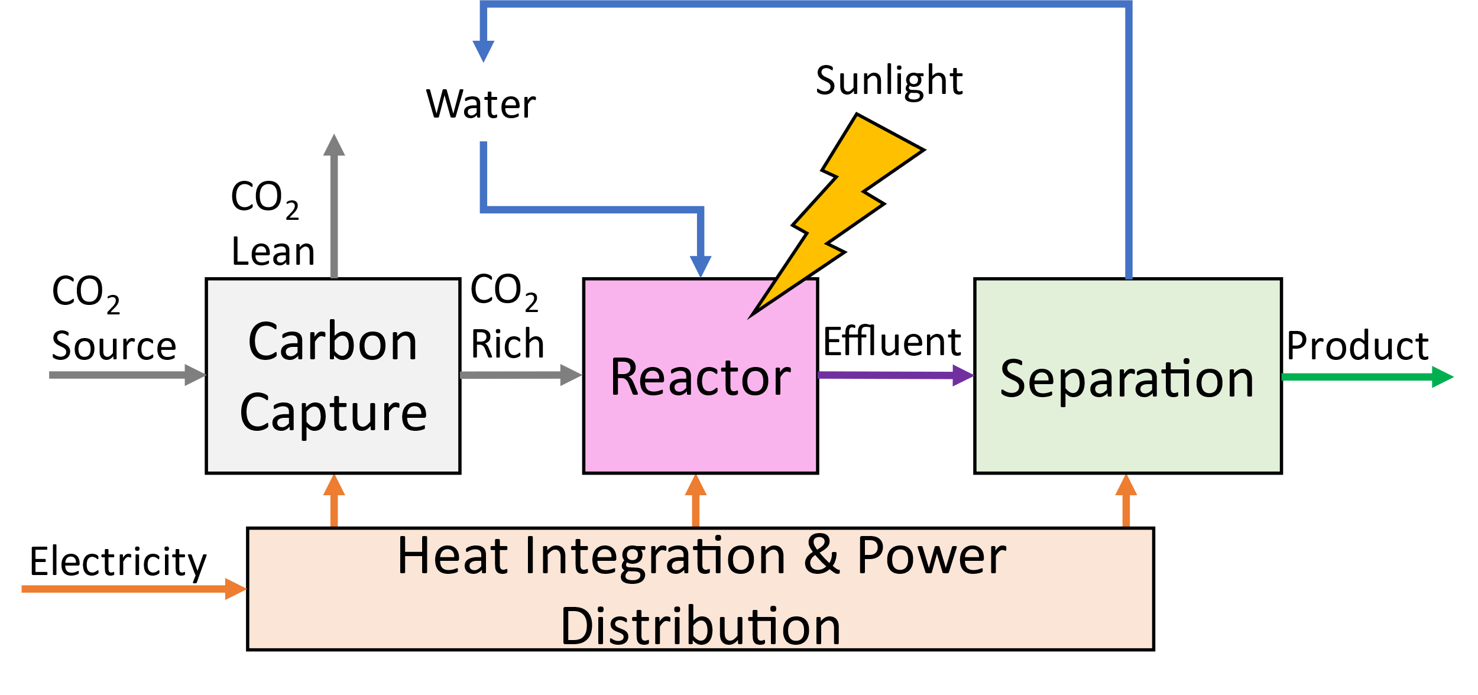

**Figure S2.1,** Overall system network graph, showing both material and energy flow. Waste Media from the separation subsystem is recycled back into the reactor.

### Carbon Capture

#### Summary

For the purpose of this study, carbon capture encompasses two primary aspects crucial to its understanding and implementation, shown in Figure S2.2.

1. **CO2 Separation:** This aspect involves the separation of carbon dioxide (CO2) from the flue gas or emission sources. Various separation technologies, such as absorption, adsorption, or membrane processes, are employed to selectively capture and remove CO2 from the gas stream. This step ensures efficient and effective extraction of CO2.
2. **CO2 Pumping into the Tank**: Once the CO2 is separated, it needs to be safely transported. This aspect focuses on the pumping and injection of the captured CO2 while adhering to safety protocols and regulatory requirements.

#### Design Considerations

While the primary focus of this report is not the Carbon capture subsystem, there were six crucial design considerations that were required for costing estimates of this subsystem.

1. **Adequate Pumping Pressure Provision**
2. **Pump Efficiency**
3. **Reactor Purity Requirement**
4. **Separation Efficiency**
5. **CO2 Recovery**
6. **CO2 Source** (Atmospheric (480ppm) or Flue Gas (14%))

### Carbon Conversion

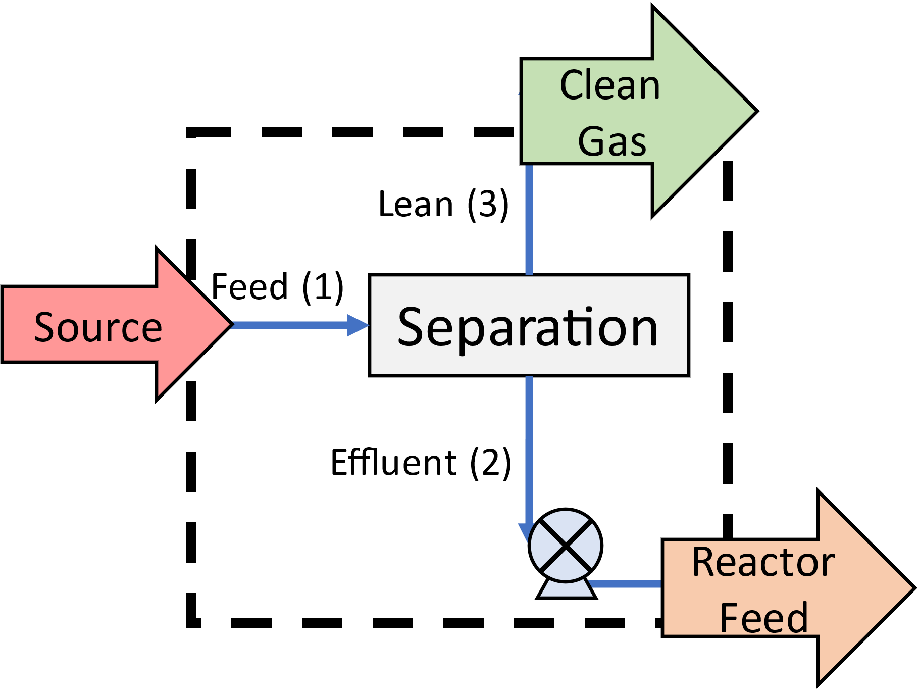

**Figure S2.2** Separation subsystem process flow diagram showing separation & pumping

#### Summary

In this Techno-Economic Assessment (TEA), the Reactor subsystem is a critical component of the overall system design and the focus of this study. The Reactor subsystem encompasses two fundamental aspects as illustrated in Figure S2.3.

1. **Pumping of H2O into the System:** The efficient pumping of water and growth media into the reactor system is a critical component of the Reactor subsystem. The proper control and management of flow is essential to maintain optimal reactor performance, ensure adequate reactant supply, and facilitate the desired biochemical reactions.
2. **Bio-Electrosynthesis**: The core process within the Reactor subsystem is bio-electrosynthesis, driven by both light and electricity. Light energy, from solar radiation, is a vital input for the biochemical reactions occurring within the reactor. Additionally, electricity is employed to facilitate electrochemical processes, providing the necessary energy and electrons required for the bio-electrosynthesis to proceed effectively.

#### Design Considerations

In this Techno-Economic Assessment (TEA), the reactor subsystem takes center stage, prompting the evaluation of several design choices that have been assessed in detail. These choices include:

1. **System Conversion (%CO2 converted)**
2. **System Energy Draw (kWh/kgCO2)**
3. **Specific System Volume (m3/kgCO2)**
4. **Reactor Height**
5. **Electrode Material**:
6. **Electrode Area**
7. **Membrane Material**
8. **Membrane Area**
9. **Final Produc**t

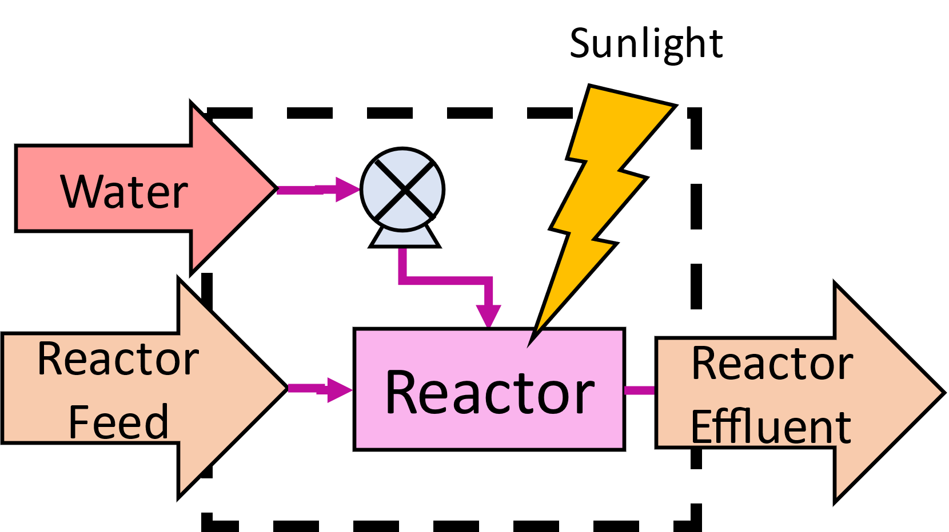

**Figure S2.3,** Reactor subsystem Process Flow Diagram. Water (growth media) is fed in as a raw material, Reactor Feed indicates the effluent from the Capture subsystem and reactor effluent is the Product rich stream. This design is undertaken assuming continuous operation. There are two aspects to this block, water pumping and CO2 conversion using electricity and sunlight catalysed by bacteria.

### Bioseparation

#### Summary

Bio separation plays a crucial role in the biotechnology and biopharmaceutical industries, involving various processes such as recovery, isolation, purification, and polishing of valuable products. Although separation itself may not be the primary focus, the associated costs can have a substantial impact on the economic viability of the overall system. As illustrated in Figure S2.4, the separation step is indispensable for product recovery and purification, demonstrating its essential role in the overall process.

#### Design Considerations

While the primary focus of this report is not the separation subsystem, there were four crucial design choices that were required for costing estimates of this subsystem:

1. **Final Product**
2. **Reactor Effluent Conditions**
3. **2nd Law Efficiency**
4. **Product Recovery**

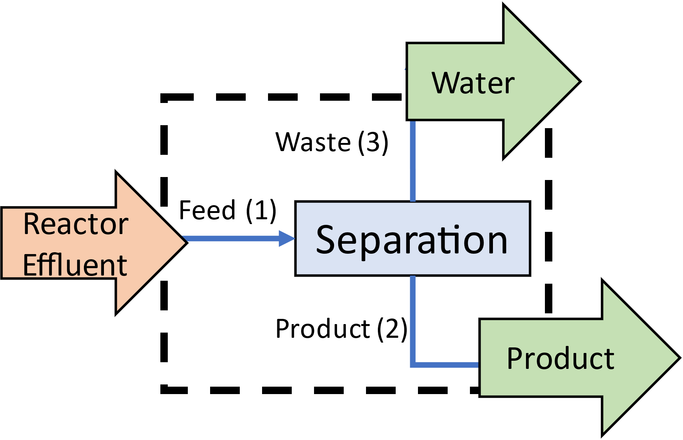

**Figure S2.4,** Separation Subsystem Process Flow diagram showing separation of reactor effluent into product stream(s) and ‘water’. The ‘water’ can then be recycled back into the reactor.

## OPEX Estimates

When considering OPEX, which includes energy, material and maintenance expenses, our focus was on energy costs and maintenance expenses. Maintenance was estimated as 10% of the total CAPEX, a common approach for novel systems, representing complete plant replacement every 10 years [1], and labor costs were taken as 20% of base OPEX (excluding maintenance)[1] Energy costs were determined based on prevailing electricity rates.

### Carbon capture

#### Separation

To address the wide variety of potential feed and effluent compositions, we used a method based on the second law of thermodynamics to calculate the system's energy needs and operating costs. We can calculate the minimum energy required for separation using the equation below, which considers the chemical potential of both the incoming and outgoing streams. This approach helps us estimate the lowest possible energy consumption and related operating costs.

$$W_{min}=RT\sum_{k}{(N_{2}x_{2,k}\ln\left\{\frac{x_{2,k}}{x_{1,k}}\right\}+N_{3}x_{3,k}\ln\left\{\frac{x_{3,k}}{x_{1,k}}\right\})}$$

In practice, separation systems' efficiencies vary widely, typically between 5% and 40% [2], [3], [4]. It's generally seen that efficiency drops as the required concentration factor goes up. For our analysis, we chose a fixed efficiency of 20%, a figure commonly associated with CO2 capture from flue gas [2], [3], [4], to simplify our calculations and provide a realistic efficiency estimate.

#### Pumping

To calculate the pumping costs for the separator subsystem, we analysed the volumetric flow rate exiting the separator at different purities. From this, we estimated the energy required to achieve a head of 3m, allowing us to calculate the pumping costs. The specific equations used for this calculation are detailed in the Supplementary Information.

### Carbon Conversion

Bioreactor operating costs can be broken down into two main aspects:

1. Reactor Costs
2. material costs (water)

Given the early stage of this assessment, we opted to neglect material costs in operational expenditure, and instead applied a 20% margin to operational costs [1].

Operational reactor costs consist of two primary components: electrical duty and heating duty. The data for electrical duty was obtained through experimental investigations[5], [6] and is parameterized as kilowatt-hours per kilogram of CO2, taking into account the system configuration and material choices, as described in the supplementary info. These electrical costs had two components: lighting costs, and electrochemical costs. Lighting cost estimates were conducted assuming a constant light supplied solely by LED’s, with required light intensity obtained from prior experiments[5], [6]. Similarly electrical costs required to drive the electrochemical reaction were obtained based on experimental data.

### Bioseparation

Similar to the carbon capture subsystem, we utilized a second law basis to estimate the operational costs of the separation subsystem. Considering the low initial purity of the product and its tendency to bind with water, we estimated second law efficiency as 0.5% [4], [7].

## CAPEX Estimates

This study utilized three main model types to estimate capital costs, each employing distinct approaches to improve accuracy and comprehensiveness:

**Energy-Based Models:** These models estimate capital costs based on the energy required for system processes. The Lange equation, commonly used for 1st Order or Order of Magnitude estimates of separation system costs[7], is employed. The equation relates the Inside Battery Limits (ISBL) cost to the required energy (E), measured in megawatts (MW).

$$ISBL_{i}=8.6⋅{E_{i}}^{0.55}$$

**Literature-Based Results Using the 6/10ths Rule:** Capital cost estimation was conducted by referencing relevant literature and employing the widely recognized 6/10ths rule [1]. This rule provides a general guideline for estimating capital costs based on pre-existing plants or equipment of a given scale. By utilizing literature-based data and applying the 6/10ths rule, a preliminary estimation of the capital costs was obtained.

**Equipment-Based Models:** In addition to the above approaches, an equipment-based model was employed to enhance the accuracy of the capital cost estimation. This model involved considering specific equipment, their associated costs, and any additional expenses related to installation and commissioning. By focusing on the detailed equipment specifications and their respective costs, a more precise estimation of the capital expenses can be achieved. For certain equipment scale-based models of cost exist with a simplified form as described below [1].

$$c=a+b{\left(s\right)}^{n}$$

By employing these three model types, this study sought to capture a comprehensive understanding of the capital costs associated with the engineering project. The literature-based approach provided initial insights, and was used where detailed flow sheeting was unknown, while the equipment-based model enabled a more detailed assessment, incorporating specific equipment considerations and associated expenses. For the Carbon Capture and Separation subsystems we primarily employed the Lange equation, while for the Reactor subsystem we primarily employed equipment-based design and the 6/10ths rule.

### Correction Factors

In the evaluation of engineering projects, the precision of capital cost estimations is crucial for assessing project viability and economic soundness. Initial capital cost estimates often vary from the final expenses due to the inherent uncertainties and the complex nature of project development. To mitigate these discrepancies, applying capital cost adjustments is essential [1].

A common method for adjusting capital costs involves the use of Lang factors [1]. These are dimensionless coefficients that adjust initial equipment cost estimates by considering factors such as project size, location, technology used, installation costs, and current market conditions. In our case, a Lang factor of 4 [1] was applied to estimate the total initial capital.

For specific equipment, cost corrections were implemented using the Chemical Engineering Plant Cost Index (CEPCI) [8] to adjust for inflationary effects. For equipment sizes that fell outside standard correlation ranges, the 6/10ths rule was employed to estimate costs more accurately.

## Statistical testing

Statistical comparisons across groups were performed using a multi-step approach. First, an overall test for differences in group means was conducted using Welch’s analysis of variance (ANOVA). Welch’s ANOVA is particularly suitable when the assumption of equal variances is not met, offering a robust alternative to the standard one-way ANOVA. A significance threshold of p < 0.05 was applied; if the overall test indicated significant differences among groups, further pairwise comparisons were warranted.

Subsequently, pairwise comparisons were carried out using the Games-Howell post-hoc test. This test is tailored for situations where groups may differ in both variances and sample sizes, providing adjusted p-values for each comparison. To enhance the interpretability of these comparisons, a bootstrap resampling procedure was employed. For each pair of groups, 10,000 bootstrap samples were generated from the observed data, and the proportion of samples in which one group’s mean exceeded the other’s was computed. These estimates—yielding probabilities that an observation from one group is greater than the other’s (P(A > B)) and vice versa (P(B > A))—offer an intuitive measure of effect size.

## Key numbers

Table 1 Key parameters for complete system at the operating point

|  |  |  |  |  |  |  |  |
| --- | --- | --- | --- | --- | --- | --- | --- |
| Parameter | Value | Units | Desc. | Distribution | Span (proportion) |  | System |
| $$C_{LANGE}$$ | 8.6 | £M | Lange capital | Random Uniform | 1 | [7], [8] | (1), (3) |
| $$f_{LANG}$$ | 4 | [-] | Lang factor | N/A | 0 | [7], [8] | (1), (2) |
| $$c_{elec}$$ | 0.28 | £/kWh | Electricity cost | N/A | 0 | [9] | (1),(2),(3) |
| $$a_{pump}$$ | -1250 | £ | Pump Constant | Random Uniform | 1 | [1], [8] | (1) |
| $$b_{pump}$$ | 2400 | £ | Pump Pre Exponent | Random Uniform | 1 | [1], [8] | (1) |
| $$n_{pump}$$ | 0.9 | [-] | Pump Exponent | Random Uniform | 0.5 | [1] | (1) |
| $$E_{CO2}$$ | 15.64 | Wh/kg | CO2 Energy | N/A | 0 | [1] | (1) |
| $$P_{0}$$ | 30 | kPa | Pump Pressure | Random Uniform | 1 |  | (1) |
| $$η_{pump}$$ | 0.8 | [-] | Pump efficiency | Random Uniform | 1 | [1] | (1) |
| $$η_{cap}$$ | 0.9 | [-] | Capture Efficiency | Random Uniform | 1 |  | (1) |
| $$η_{conv}$$ | 0.85 | [-] | Conversion Efficiency | Gaussian | 1/3 |  |  |
| $$η_{2nd,CC}$$ | 0.2 | [-] | 2nd Law Efficiency | Random Uniform | 1 | [2], [3], [4] | (1) |
| $$p_{CO2}$$ | 95 | Mol.% | Outlet CO2 Purity | Random Uniform | 0.2 |  | (1) |
| $$p_{Flue}$$ | 15 | wt.% | Flue Gas Purity | Random Uniform | 1 | [3], [10], [11] | (1) |
| $$P_{DAC}$$ | 480 | ppm | Air CO2 | Random Uniform | 1 | [12] | (1) |
| $$a_{Reactor}$$ | 0.129 | £M | Reactor Constant | Gaussian | 1/3 | [1], [8] | (2) |
| $$b_{Reactor}$$ | 3700 | £ | Reactor Pre-Exponent | Gaussian | 1/3 | [1], [8] | (2) |
| $$n_{Reactor}$$ | 0.65 | [-] | Reactor Exponent | Lognormal | 1/3 | [1] | (2) |
|  | 8 | m2 | Membrane Area @ 1 tonne scale | Gaussian | 1/3 | [5], [6] | (2) |
|  | 40 | m2 | Electrode Area @ 1 tonne scale | Gaussian | 1/3 | [5], [6] | (2) |
| $$E_{0}$$ | 2.3E+3 | kWh/tonne | Reactor Electricity Draw | Lognormal | 1/3 | [5], [6] |
| $$PPFD$$ | 0.5 | kW/Tonne/yr | Req. Lighting | Gaussian | 1/3 | [5], [6] |
| $$C_{LED}$$ | 65 | £ | Ref. LED Cost (1W) | Lognormal | 1/3 | [1], [8] |
| $$E_{∅}$$ | 688.3 | kWh/kmol | Ideal Energy Coefficient | N/A | 0 | [1] |
| $$x$$ | 0.1 | kgCO2e/kgwater | CO2 equiv. Mass fraction | N/A | 0 |  |
| $$η_{2nd,BS}$$ | 0.005 | [-] | 2nd Law efficiency | Random Uniform | 1 | [4], [7] |
| $$p_{co2e}$$ | 0.1 | kgco2e/kgwater | Mass fraction of reactor effluent | Random Uniform | 1 |  |

Table 2 Key Cost parameters for electrode Materials

|  |  |  |  |
| --- | --- | --- | --- |
| Membrane | Cost/ £ m-2 | Effectiveness |  |
| Nafion | 500 | 1 | [13] |
| Biochar | 45 | 0.8 | [14] |
| Earthenware | 10 | 0.7 | [15] |

Table 3 Key Cost parameters for electrode Materials

|  |  |  |  |
| --- | --- | --- | --- |
| Electrode | Cost/ £ m-2 | V0/ m3 tonne-1 yr. |  |
| RVC | 450 | 0.14 | [16], [17] |
| Carbon felt | 60 | 13.3 | [5], [6], [18] |

Table 4 Key Cost parameters for Different products

|  |  |  |  |  |  |  |
| --- | --- | --- | --- | --- | --- | --- |
| Product | Value/ £ mol-1 | Mr/ g/mol | ‘C’ Ratio/ kgCO2/kgx | Req. Purity | $$η_{cap}$$ |  |
| Biomass | 7.5E-3 | 25 | 1.76 | - | - | [19] |
| PHB | 1.5 | 186 | 2.126 | 0.5 | 0.9 | [20] |
| B2(RF) | 25 | 376 | 1.99 | 0.99 | 0.98 | [21], [22] |

## References

[1] G. Towler and R. Sinnott, *Chemical Engineering Design*. Elsevier, 2022. doi: 10.1016/C2019-0-02025-0.

[2] L. Irlam, “GLOBAL COSTS OF CARBON CAPTURE AND STORAGE 2017 Update,” 2017.

[3] “Cost of CO2 capture from large-scale coal-fired power plants – Charts – Data & Statistics - IEA.” Accessed: Apr. 25, 2022. [Online]. Available: https://www.iea.org/data-and-statistics/charts/cost-of-co2-capture-from-large-scale-coal-fired-power-plants

[4] K. Z. House, A. C. Baclig, M. Ranjan, E. A. Van Nierop, J. Wilcox, and H. J. Herzog, “Economic and energetic analysis of capturing CO 2 from ambient air,” 1998, doi: 10.1073/pnas.1012253108/-/DCSupplemental.

[5] W. Tu, J. Xu, I. P. Thompson, and W. E. Huang, “Engineering artificial photosynthesis based on rhodopsin for CO2 fixation,” *Nature Communications 2023 14:1*, vol. 14, no. 1, pp. 1–12, Dec. 2023, doi: 10.1038/s41467-023-43524-4.

[6] P. A. Davison *et al.*, “Engineering a Rhodopsin-Based Photo-Electrosynthetic System in Bacteria for CO2Fixation,” *ACS Synth Biol*, vol. 11, no. 11, pp. 3805–3816, Nov. 2022, doi: 10.1021/ACSSYNBIO.2C00397/ASSET/IMAGES/LARGE/SB2C00397_0007.JPEG.

[7] M. Tsagkari, J.-L. Couturier, A. Kokossis, and J.-L. Dubois, “Early-Stage Capital Cost Estimation of Biorefinery Processes: A Comparative Study of Heuristic Techniques,” *ChemSusChem*, vol. 9, no. 17, pp. 2284–2297, Sep. 2016, doi: 10.1002/cssc.201600309.

[8] Charles Maxwell, “Cost Indices,” Towering Skills.

[9] “Quarterly Energy Prices: December 2021 - GOV.UK.” Accessed: Mar. 15, 2022. [Online]. Available: https://www.gov.uk/government/statistics/quarterly-energy-prices-december-2021

[10] H. Chang and C. Shih, “Simulation and Optimization for Power Plant Flue Gas CO 2 Absorption‐Stripping Systems,” *Sep Sci Technol*, vol. 40, no. 4, Mar. 2005, doi: 10.1081/SS-200048014.

[11] C. Song *et al.*, “Tri-reforming of Methane over Ni Catalysts for CO2 Conversion to Syngas With Desired H2/CO Ratios Using Flue Gas of Power Plants Without CO2 Separation,” 2004, pp. 315–322. doi: 10.1016/S0167-2991(04)80270-2.

[12] N. McQueen, K. V. Gomes, C. McCormick, K. Blumanthal, M. Pisciotta, and J. Wilcox, “A review of direct air capture (DAC): scaling up commercial technologies and innovating for the future,” *Progress in Energy*, vol. 3, no. 3, p. 032001, Apr. 2021, doi: 10.1088/2516-1083/ABF1CE.

[13] S. Ahmad, T. Nawaz, A. Ali, M. F. Orhan, A. Samreen, and A. M. Kannan, “An overview of proton exchange membranes for fuel cells: Materials and manufacturing,” *Int J Hydrogen Energy*, vol. 47, no. 44, pp. 19086–19131, May 2022, doi: 10.1016/J.IJHYDENE.2022.04.099.

[14] S. Zhao *et al.*, “Application of biochar in microbial fuel cells: Characteristic performances, electron-transfer mechanism, and environmental and economic assessments,” *Ecotoxicol Environ Saf*, vol. 267, p. 115643, Nov. 2023, doi: 10.1016/J.ECOENV.2023.115643.

[15] S. M. Daud *et al.*, “Improvement of microbial fuel cell performance using novel kaolin earthenware membrane coated with a polybenzimidazole layer,” *Energy Sci Eng*, vol. 9, no. 12, pp. 2342–2353, Dec. 2021, doi: 10.1002/ESE3.988.

[16] V. Flexer and L. Jourdin, “Purposely Designed Hierarchical Porous Electrodes for High Rate Microbial Electrosynthesis of Acetate from Carbon Dioxide,” *Acc Chem Res*, vol. 53, no. 2, pp. 311–321, Feb. 2020, doi: 10.1021/ACS.ACCOUNTS.9B00523/SUPPL_FILE/AR9B00523_SI_001.PDF.

[17] “Black Reticulated Vitreous Carbon Foam Electrode at Rs 9500/kg in Kaithal.” Accessed: Mar. 29, 2024. [Online]. Available: https://www.indiamart.com/proddetail/reticulated-vitreous-carbon-foam-electrode-23342962288.html

[18] “2-10mm Soft Graphite Carbon Felt for Energy Storage Battery Electrode Graphite Fiber Conductive Carbon Felt - AliExpress.” Accessed: Mar. 29, 2024. [Online]. Available: https://www.aliexpress.com/i/1005005745658077.html

[19] “Animal feed prices - GOV.UK.” Accessed: Mar. 29, 2024. [Online]. Available: https://www.gov.uk/government/statistical-data-sets/animal-feed-prices

[20] B. Alvarez Chavez, V. Raghavan, and B. Tartakovsky, “A comparative analysis of biopolymer production by microbial and bioelectrochemical technologies,” *RSC Adv*, vol. 12, no. 25, p. 16105, May 2022, doi: 10.1039/D1RA08796G.

[21] “Riboflavin | Price | per kg | USD | PharmaCompass.com.” Accessed: Mar. 29, 2024. [Online]. Available: https://www.pharmacompass.com/price/riboflavin

[22] “Riboflavin Price, 2024 Riboflavin Price Manufacturers & Suppliers | Made-in-China.com.” Accessed: Mar. 29, 2024. [Online]. Available: https://www.made-in-china.com/products-search/hot-china-products/Riboflavin_Price.html